EXERCISE NUMBER:2

DATE:14/10/2020

AIM:

To Write a Python function countX(lst, x) to count the number x in a given list of numbers.

*PROGRAM:*

def countX(list,s):

c=0

for i in range(0,len(list)):

if(list[i]==s):

c+=1

print(c)

list=[]

x=int(input())

for i in range(0,x):

list.append(int(input()))

s=int(input())

countX(list,s)

LINK:

http://103.53.53.18/mod/vpl/forms/edit.php?id=230&userid=1747

OUTPUT:

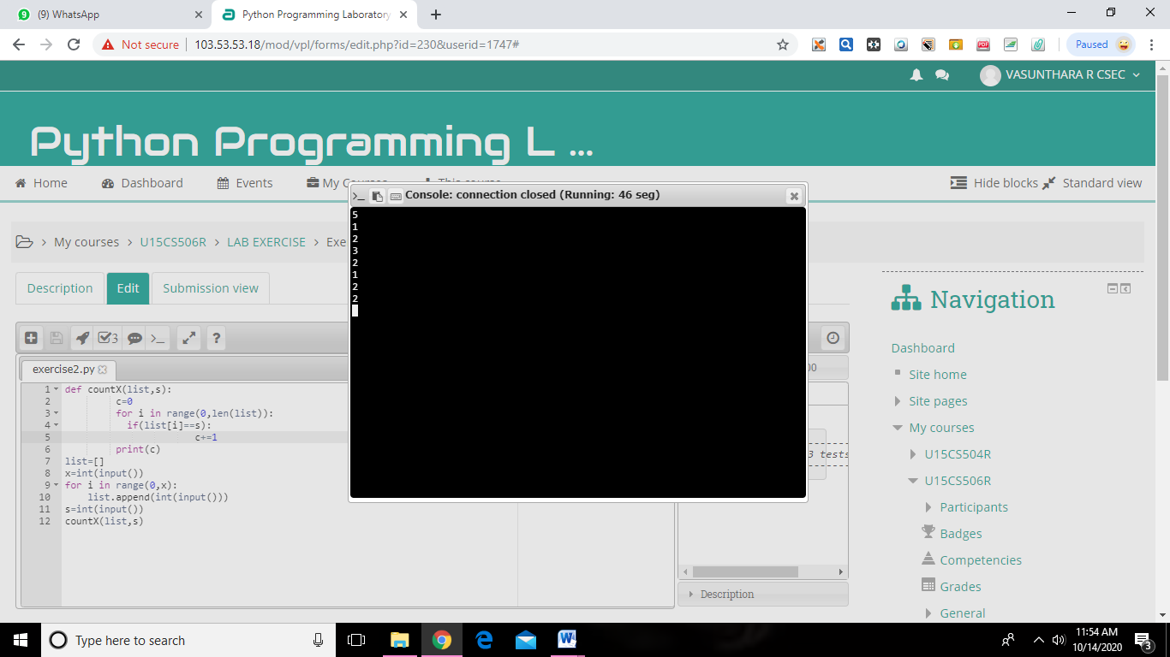

RESULT:

The expected output is obtained successfully